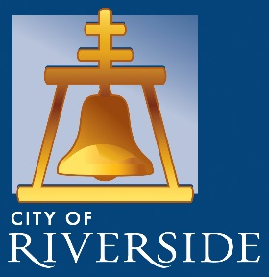 News Release

FOR IMMEDIATE RELEASE:

July 28, 2026

Contact:
Dr. Cheryl-Marie Hansberger
Office of the Mayor, City of Riverside
(714) 343-1102
cmhansberger@riversideca.gov

Gomez Family to Reveal Mosaic Artwork to Honor Lives Lost in Route 91 Tragedy
City of Riverside, Neighborhood Engagement Division’s Small Sparks Grant integral to completion of “Angela’s Wings” project

RIVERSIDE, Calif. – On September 28, at noon, the Gomez family, supported by the Office of the Mayor, will reveal the public art mosaic “Angela’s Wings.” The art piece is located on the alley wall of Mario’s Place restaurant, 3646 Mission Inn Avenue, directly across from the entrance to the historic Mission Inn Hotel and Spa.

Mosaic artists Greg and Cathy Maxwell were commissioned to create Angela’s Wings in collaboration with Mario’s Place, Dal Tile, the City of Riverside’s Neighborhood Engagement Division, The Community Foundation, Angela’s Wishes -The Angela C. Gomez Memorial Foundation and the Riverside Arts Council. “I am proud to see our community come together to help honor Angela, Riverside’s sweetheart, through the dedication of a lasting legacy,” said Mayor Rusty Bailey.

On October 1, 2017, twenty-year-old Riverside native Angela C. Gomez lost her life at the hands of a lone gunman who shot and killed 58 people and injured 822 people at the Route 91 Harvest Music Festival in Las Vegas. “As the two year mark of October first approaches, the days get more difficult, even more than each day already is,” said Steve Gomez, Angela’s father.

Angela’s Wings commemorates the lives of each individual killed in the Route 91 shooting. A bronze plaque with the names and birthdates of the 58 “Route 91 Angels” will be mounted next to the mosaic. “The mosaic is intended to represent peace and faith to survivors of the tragedy and the community of families that lost loved ones that day,” Angela’s mother, Julie Gomez, said. “We hope this angel wings mural will be a place of beauty, comfort and healing for all who deeply love and miss their angels.”

Angela’s-Wishes
To learn more about The Angela C. Gomez Memorial Foundation, please visit https://angelaswishes.org/.

