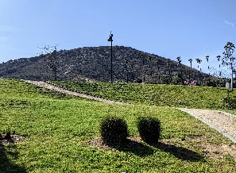
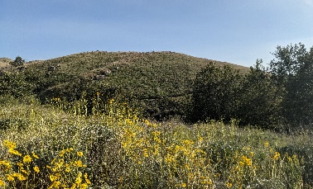
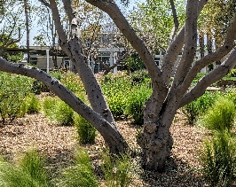
City of Riverside Outdoor Adventure Journal
Chapter Four

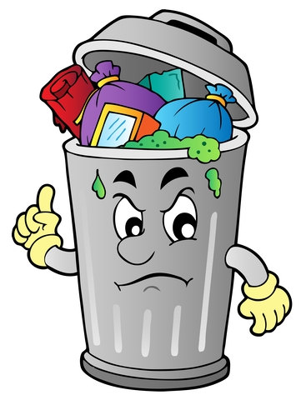
Talking Trash
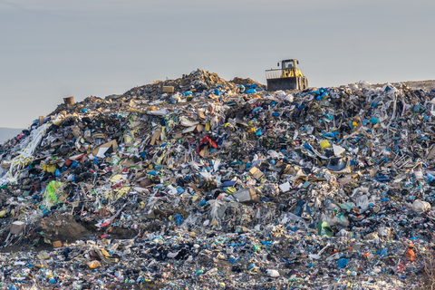
Do you know where your trash goes after the garbage truck picks it up? A lot of it will go to a landfill or “the dump”. But with our communities growing and our use of “stuff” increasing, these land fills are filling up. That means new landfills must be dug. Anything in a landfill that contains toxic materials (like plastics) can leach those toxins into the soil and ruin it. When rain and runoff pass through this same soil, water can be contaminated as well. The more we reduce the “stuff” we use, reuse things instead of buying new, and recycle materials that can be changed into something else, the less garbage we put in our landfills.

Keep reading to find activities you can do to reduce what goes into a landfill.

Compost Green Garbage
Compost is organic material that has broken down (biodegraded) into high nutrient soil with the help of some busy microbes. Biodegradable materials such as leaves, shredded twigs, and kitchen scraps from plants, a bit of moisture, and some time can easily become the gardener’s “black gold.”
Materials
- Recycled plastic bottles (2-liter bottles work well)
- Fruit and vegetable scraps which contain nitrogen and will ensure decomposers/micro-organisms that will break down materials reproduce quickly.
- Brown trash like dead leaves and twigs and paper shreds contain high amounts of carbon which provides a food source for the decomposers.
- Oxygen and water which are required by all living things, including the micro-organisms.
- A bit of soil from somewhere outside (not potting soil)
- A nail
- Scissors (get an adult to cut your water bottles).

Directions

- Rinse the bottle and have a grown up cut off the top of the bottle, about 2 inches below the pour spout and poke 8-10 air holes in the sides with the nail.
- Add a small layer of dirt to the bottom of the bottle, followed by a small layer of brown trash, then a small layer of fruit/veggie scraps. The more the scraps are chopped up, the faster they will decompose. Repeat the layers filling the bottle until about an inch and a half from the top.
- Add a SMALL amount of water; if you have a spray bottle this would work best.
- Put the lid on the pour spout, turn it so the lid fits into the top of the cut opening of the bottle and place in a sunny spot.
- Once a week use a stick or other long object, remove the top and stir the compost. Make a note of how it has changed.
- Spray with small amount of water as the compost dries out. If it looks slimy, remove the top for a while.
- This process will take weeks, depending on temperature and water conditions. You may see bits of mold form. Be sure you don’t use too much water. When your compost looks like dark rich soil it is ready to use in your garden, or you can just plant seeds right in your water bottle compost bin!

If you haven’t already, check out the book “Compost Stew” in the Earth Month Story Time Read Aloud books from week two! https://riversideca.gov/press/earth-month-2021

Looking for Your Personal Best

This month we have looked at ways our planet could use help staying healthy. We have learned the best way to be sustainable and keep Earth “green” is for each person to take their own actions seriously. Use the sustainability audit below to help you see how well your home and family are doing to protect our Earth. You may need help from your parents with a few of the questions, but most can be answered by YOU. Give yourself a point for each “Yes” answer.

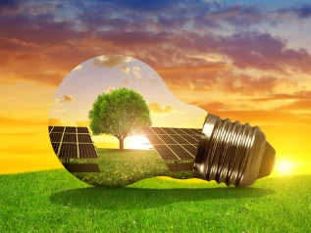
Energy

- Do your light fixtures use LED light bulbs that save money and electricity over the lifetime of the bulb? _____
- Do you turn off the lights in a room when you leave and nobody else will be in the room? _____
- Do you turn off your computer when it is not in use for prolonged amounts of time, instead of letting it stay in “sleep” mode for hours? _____
- Ceiling fans don’t cool the room, they just make people feel cool as air blows over their skin. If your home has ceiling fans, do you turn off the fans when nobody is home? _____
- Do you turn off the television when it is not being watched? _____
- Vampire Load is when appliances, though not in use, remain plugged in and still consume small amounts of electricity. This is especially true for gaming consoles that can have constant updates. Do you unplug chargers and devices when they aren’t being used? _____
- If you plug devices into a power strip, the power strip can be turned off instead of unplugging devices. Do you use a power strip you can turn off when not in use? _____
- Give yourself 10 bonus points if your home uses solar energy. _____

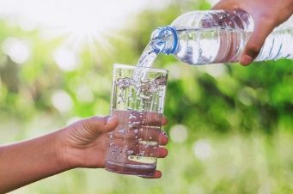
Water

- Do you turn off the water when you brush your teeth? _____
- Do you turn off the water when you soap up your hands? _____
- If you have a swimming pool, do you keep your pool covered to prevent water loss from evaporation? _____
- Do you take short showers (10 minutes or less)? _____
- Efficient showerheads, called “low flow,” deliver between 1.6 and 2.5 gallons per minute, whereas a standard showerhead delivers between 5 and 8 gallons per minute. Do you use low flow shower heads in your showers? _____
- Watering your garden during cooler times of the day greatly reduces the amount of water lost to evaporation. Do you water your garden during early morning or evening hours? _____
- Do you make sure there are no leaking faucets in your home and fix leaks immediately if you find them? _____
- Do you keep a bucket under the faucet while the water runs to heat up, and save that water to water plants or for other uses instead of letting it waste down the drain? _____

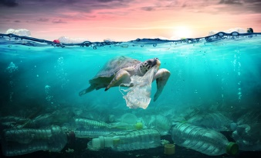
Pollution

- Do you use reusable water bottles instead of single use plastic bottles? _____
- Do you use reusable grocery shopping bags instead of single use plastic bags?
- Do you use environmentally friendly cleaning products in your home that are made of natural non-toxic products? _____
- Do you use natural methods to rid the garden of pests (like olive oil for leaf miners, lavender for ants, etc.)? instead of harsh environmentally toxic chemicals? _____
- If you have a fireplace, fire pit, or bar-b-que, do you follow SAQMD’s no burn day policies to reduce the risk of breathing problems for those with asthma and other respiratory challenges? _____
- In the kitchen, do you wash and reuse plastic storage containers, zip-lock bags, or better yet, glass containers, instead of storing food in single use plastics? _____
- Do you properly separate trash in the blue, brown, and green bins so garbage can be recycled when possible, and garbage in landfills can be reduced? _____
- Do you have a compost bin? _____
- Do you grow any of your own fruits and vegetables? _____
- Finally, give yourself 50 extra points if you talk to others about how to take care of the earth or encourage anyone in your family to practice any of these earth friendly behaviors. _____

Add up your scores from each section to get your total to find out your sustainability rank.
80 points or higher – Earth Month Superhero
70-79 points - Earth Month Pro
60-69 points - Earth Month Veteran
59 points or less - Earth Month Beginner

Thank you for joining us for Earth Month 2021. We hope you have enjoyed the stories, videos, activities, and adventures and have learned at least one thing you didn’t already know about how to protect our planet and live a clean, green sustainable lifestyle. Keep up the great work!

